OVERVIEW
Above Asia Students’ Venture Forum
Targeting all students who have a huge passion for business!
Do you have a business idea?
Develop your new or existing business ideas through Above Asia Students' Venture Forum.
You can exchange your ideas with a number of students from different countries
who have brilliant ideas in new business fields.
With diverse additional activities besides competition,
you can not only meet up with good friends from different cultural backgrounds
but also make unforgettable memories.
We all look forward to meeting you in AASVF!

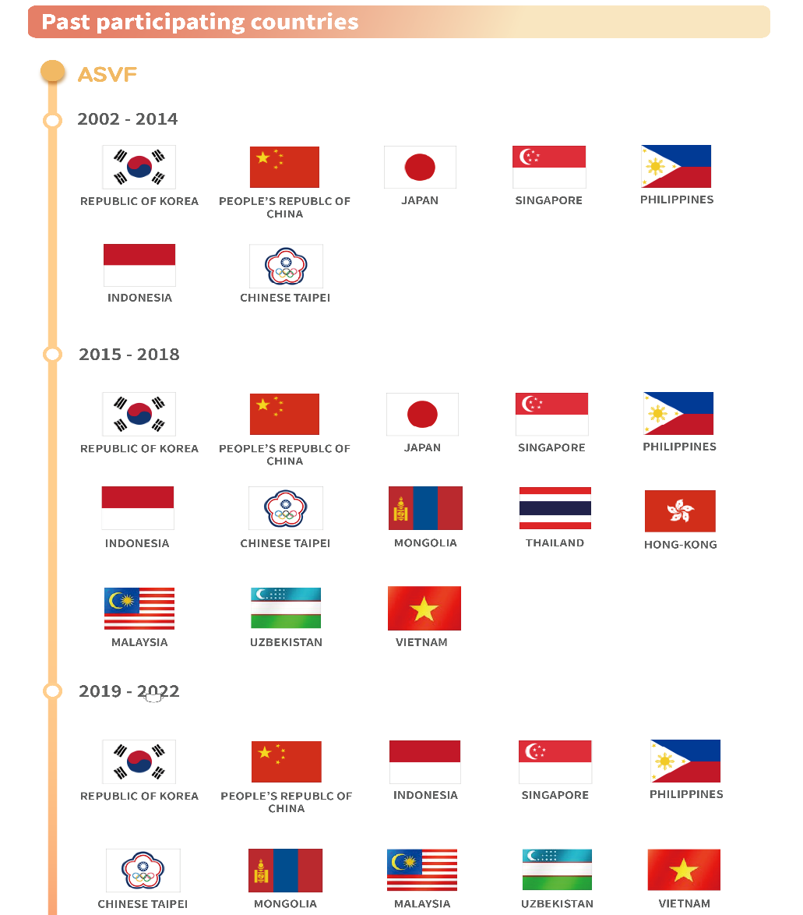
Past participating countries
※ Students from other countries are always welcomed.
※ Country standards are based on Olympics(https://www.olympic.org/national-olympic-committees)
Eligibility
- Team made up of 3 ~ 7 students from each country
- Up to two teams from each country (up to 14 applicants)
※ School alliance team is acceptable
(Alliance in one country only. Multiple countries are unacceptable)
※ There are no restrictions on ethnicity
※ Country standards are based on Olympics
※ Applicants must be at least 19 years of age(born in 2003)

Venue & Contest Schedule

Korea (* Detailed location will be announced later)
Mar. 29 | Orientation & Rehearsal  (Groups of students from each country will be formed by the organizer beforehand.  Group members will be announced on Mar. 29)
Mar. 30 | Presentation (business items) and group mission activities  (Presentation by country / Mission topics will be announced on the day)
Mar. 31 | Group Mission activities & Cultural experience  (Visiting famous places of the venue and experiencing Korean culture)
Apr. 1 | Mission activity reporting & Ending party  (Awards for mission activities and team performance of each country)
Apr. 2 | Leaving Korea
※ | The schedule is subject to change, depending on the situation

Cost
- Cost of room and board will be paid by the organizer during the contest.
Round-trip airfares and Visa, however, should be paid by applicants.
How to Apply
The application process consists of 4 steps as shown below
and all of them must be completed before the application is considered valid.
Submit to: asvf123@naver.com

1. [Submission of Application form & Idea summary: by Jan 31, 2023 (midnight)]
- The team leader is kindly requested to submit information of all team members.
- The application form is available at asvf123@naver.com

2. [Submission of immigration information (1): by Feb. 28, 2023 (midnight)]
- The team leader is kindly requested to gather and submit images of passports and plane tickets (roundtrip) of all team members.
※ It is recommended that return flights be scheduled after 4:00 pm on April 2.

※ Images for the round-trip tickets must include the receipt and flight information
(Please submit online voucher images in PDF form and not mobile phone shots)

3. [Submission of immigration information (2): by Mar. 2, 2023 (midnight)]
- The team leader is requested to gather and submit images of visas of all team members.
※ Submission of visa images is not required for students of nationalities who can clear immigration without a visa

4. [Submission of presentation / performance materials: by Mar. 28, 2023]
- The team leader is kindly requested to submit presentation materials and materials to be used in performances such as sounds and images etc.(around 7 min)

※ 한국대표는 별도의 선발절차를 통해 선발을 진행합니다. 한국대표 모집공고는 올콘 사이트 ( www.all-con.co.kr )에서 확인하실 수 있습니다.

Venture idea Presentation Requirements

1. Theme: Items for start-up (no restriction on fields)
2. Presentation Time: 7 minutes
3. File Type: Microsoft PowerPoint (Prezi not allowed). Visual materials may be used
* Please submit the presentation file together with the font file.
4. Notes
- To ensure smooth progress during the conference, there shall be no changes to the presentation file after rehearsals on the 1st.
- Presentation will be stopped by the host if presentation time is exceeded.
- Please download related materials in advance as internet connection may not be readily available
at the site of the conference.
- During the presentation, distributing any materials to the judges is not allowed.
However, test product demonstration is allowed.
- There shall be no Q & A.
- Admission into the conference is strictly prohibited for all other persons except registered participants, organizers and related parties.

Judging Criteria
- Presentation Skills (Persuade audiences well) : 20%
- Idea creativity and innovation : 20%
- Marketability or feasibility : 20%
- Idea completion (content specificity) : 20%
- Economic value of idea and effectiveness of market impact : 20%

Prizes
- Platinum Prize (1) : $ 2,000
- Gold Prize (1) : $ 1,500
- Silver Prize (1) : $ 1,000
- Bronze Prize (3) : $ 500
- Special Prize (1) : Gifts

Important Notes
- The schedule and details above may be changed by the organizer.
- Details on cultural experience and the schedule will be announced later.
- All the schedules announced are based on Korea time.
- All costs incurred before and after the contest will not be paid by the organizer.
- Each team should check in at the place of contest by Mar. 29.
- During the presentation, distributing any materials to the judges is not allowed.
However, test product demonstration is allowed.
- Each team should follow the instructions of the organizer during the event.
Any issues arising from failure to do so will not be solved by the organizer.
- Each team members should not engage in speech or actions insulting other team
members during the event.
- There is no dress code during the event. However, be sure to bring warm clothes
to Korea as it is chilly in March.
- All copies of passport and airline tickets will be disposed after the contest ends.

Contact Information
E-mail : asvf123@naver.com
Line : hyeonyeong1225
kakao talk : http://pf.kakao.com/_tvrWu

